Recon Screen Document v2
Nov 2, 2026 · @Unnati Sharma
This is the redesigned Recon front end, screen by screen. Every screen keeps the existing business logic — rules only, both figures and both sources on every finding, decisions never overwritten, roles unchanged — and improves the journey, layout and hierarchy around it. All screenshots are the real React + Vite build running on the built-in Test Pack A demo engine (the fictional Nimbus Logic Systems Private Limited).

1. What changed and why
The biggest change is the Client file: a reviewer can now read a finding, decide it and move to the next open one without scrolling, using either the mouse or three keys. Everything else follows the same pattern of summary first, detail second.
Area | Before | After | Why
Navigation | White sidebar with four text links; sign-out, theme and shortcuts loose at the bottom | Navy rail with icons, live counts (open findings, items to classify), tax-year switcher, Ctrl K search, user menu holding theme, password and sign-out; collapses to icons with [ | Users always know where they are and what is waiting; tax year is a global choice, so it lives in the rail
Season board | Six large KPI cards that did nothing when clicked; plain table | One KPI strip whose tiles filter the table, a season progress bar, status chips with counts, findings shown as open-of-total with a progress meter | The board answers "which client needs me next" at a glance
Empty board | One sentence pointing at Add client | Three-step onboarding (add, upload, decide) | First-time users see the whole journey
Add client | Centred modal, long scroll, GSTIN added through a separate button | Right-side drawer with labelled sections, live PAN/TAN/GSTIN validation, state read from the GSTIN, a warning when the GSTIN does not contain the PAN, Ctrl Enter to save | Fewer wrong entries, and the board stays visible behind the form
Client file header | Title, then a separate upload panel, then a text summary line | One header row: identity chips, tax year, Export, Upload and run; files can be dropped anywhere on the page | Primary action is always in the same place
Result summary | Five numbers in a row | Numbers plus a pass / findings / cannot-check bar and an "open, no decision yet" counter | The size of the problem reads before the numbers
Findings | Seven filter dropdowns above a long page; list and detail scroll away from each other | Segmented result filter with counts, compact filter bar, sticky grouped list beside the detail, collapsible document groups | The work happens in one view
One finding | Figures, difference and sources in a card; three identical yellow buttons | Figures as rows in one table (A, B, Difference) with label, source file, copyable location and amount, rule basis with a link to the rule, three distinct decision cards (F, X, A keys), automatic move to the next open finding, decision history timeline | Faster deciding, and the history is visible where the decision is made
Upload and run | Plain file input and chips | Drop zone, per-file recognition result before running, tax-year note, a four-step progress view while the run happens | Users see what will be read before they press Run
Teach this layout | One long scrolling form | Three-step wizard with suggested columns, the first row of the file shown beside the mapping, and Save enabled only after a clean preview | Mapping is checked against real data at every step
Documents | A list and a table repeating the same files | Files grouped with their documents, a coverage bar of read vs not read, and a drawer showing every value and why it was not read | One table instead of two
Run history | Text list | Timeline with a result bar per run, change in findings from the previous run, and Open read only | Trends across runs are visible
Worklist | Large KPI cards and one card per item | Progress bar, change-type filter chips, a dense table with a 12-month entry strip, inline classification with suggestions, bulk classify bar, Undo on every save | Twelve items fit on one screen; classifying is a type-and-Enter job
Rules | Two rows of filters and a paginator card above the table | Clickable status KPIs, one filter row, sortable table, detail in a drawer with a readiness check that explains why Approve is or is not available | The rule book is scannable and approval is self-explaining
Rule Builder | Long modal | Full page with section navigation, a live sentence describing what will raise a finding, required examples, a fixed action bar and Ctrl S | A CA can check the rule reads right before saving
Admin | Users, add-user form, lockout and audit log stacked on one page | Three tabs (Users, Sign-in security, Audit log); add and manage in dialogs and drawers; role picker that explains each role; filterable audit log | Each task gets its own space

2. Design system
One token file (src/styles/tokens.css) holds every colour, size and timing; components never use raw values. Light and dark themes share the same token names, and the theme follows the computer unless the user picks one.

Colour
Token | Light | Dark | Used for
Brand (saffron) | #F5C518 | #F5C518 | The one primary action per screen, active nav marker, current-run dot
Ink / nav (navy) | #0B1530 | #0B111F | Navigation rail, rule-ID chips, client avatar
Accent (blue) | #2546C4 | #8AA4FF | Links, focus ring, selection, read coverage
Background / surface | #F3F4F7 / #FFFFFF | #0A0E18 / #111725 | Page and cards
Text / secondary / faint | #121A2C / #475066 / #6F788C | #E8EBF3 / #AAB2C5 / #8790A6 | Three text levels, all at least 4.5:1
Danger | #B42318 | #FF8A7F | Findings, differences, Fix, destructive actions
Success | #157347 | #5FD39A | Pass, Not an issue, decided progress
Warning | #965A00 | #F3B85A | Cannot check, testing rules, missing months
Violet | #6440C4 | #B9A2FF | Ask client, step change
Semantic colours always come with an icon or a word, never colour alone.

Type, spacing and shape
Token | Values | Notes
Fonts | Inter Variable (UI), JetBrains Mono Variable (IDs, PAN, file locators) | Bundled with the build, so they work offline
Type scale | 11 / 12 / 13 / 14 (body) / 16 / 20 (page title) / 24–26 (numbers) px | Page titles stay at 20 px so headers do not eat the screen
Weights | 420 regular, 520 medium, 620 semibold, 700 bold
Numbers | Tabular figures, Indian grouping, always two decimals: ₹1,38,310.00 | Amounts are kept as whole paise
Spacing | 4 px grid: 4, 8, 12, 16, 20, 24, 32, 40 | Page gutter 28 px, 16 px under 900 px
Controls | 28 / 34 / 40 px heights; table rows 44 px (38 px compact) | One input height across all forms
Radius | 6 (small), 8 (controls), 12 (cards), 16 (dialogs), pill
Elevation | xs on cards, md on menus, lg on dialogs and drawers only | Shadows mark layers, not decoration
Motion | 120 / 180 / 280 ms, ease-out; off under reduced-motion | Rise-in on pages, slide-in on drawers, pop-in on dialogs

Components
Component | Where | Behaviour
Button (primary, secondary, ghost, danger, danger-ghost; sm / md / lg) | Everywhere | Loading spinner, disabled state, optional key hint
Field, input, select, textarea, switch, checkbox, radio cards, segmented control | Forms and filters | Label, required star or "Optional", hint or inline error with icon
Badge, count, filter chip, chip | Status, counts, filters, GSTINs | Tone plus dot or icon
Card, KPI strip, stack bar, meter, month strip | Summaries | KPI tiles can act as filters
Table with sortable headers, group rows, pagination | Lists | Keyboard row focus, selected-row marker
Dialog, drawer, confirm dialog with required reason | Forms and detail | Focus trap, Esc closes the top layer only, focus returns to the trigger
Toast with Undo | After every save | Polite live region
Empty state, skeleton, error panel | Loading and no-data states | Every list has one
Command palette, menu, shortcuts sheet | Shell | Arrow keys and Enter

3. Navigation and keyboard
The rail is the same on every screen and is not a sticky header, so no vertical space is lost. The Client file still opens from the Season board, and Esc still goes back to it.
- Tax year sits at the top of the rail and sets the year for the Season board, Worklist and new clients.
- Search or jump (Ctrl K) finds a client by name or PAN ending, a rule by ID or name, or an action (Add client, Add rule, switch theme, shortcuts).
- Counts on the rail: Season board shows open findings across the season; Worklist shows items still to classify.
- User menu at the bottom holds theme (light, dark, match the computer), keyboard shortcuts, change password, audit log (Partner) and sign out.
- Engine status above the user shows whether the screens can reach the engine.
- Collapse with the round button or the [ key; the choice is remembered on that computer.
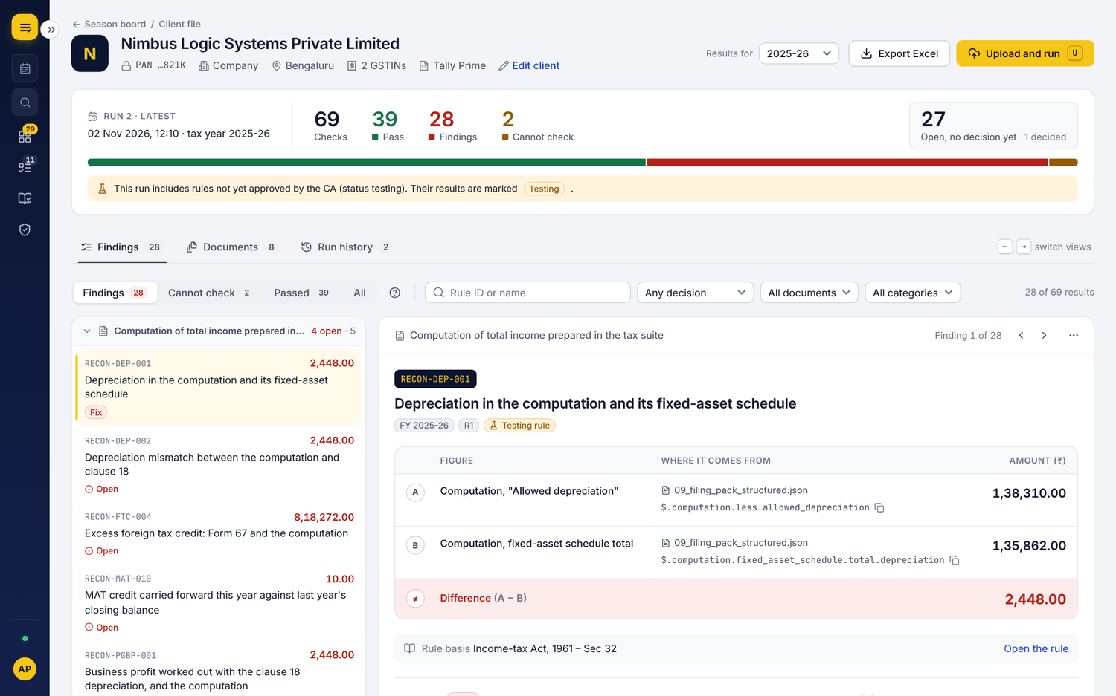
Keys | Action
1 – 4 | Season board, Worklist, Rules, Admin (Partner)
Ctrl K | Search clients, rules and actions
/ | Search the current list
↑ ↓ or j k | Move between rows or findings
Enter | Open the row
n | Add client (Season board)
u | Upload and run (Client file)
← → | Findings, Documents, Run history
f / x / a | Decide: Fix / Not an issue / Ask client
Ctrl Enter, Ctrl S | Save the client form, save a rule as testing
Esc | Close the top panel, or go back to the Season board
? | Shortcuts sheet
Single keys never fire while the user is typing in a field.

4. First start and sign-in

4.1 Set up the first Partner
Shown once, on an empty database. Login name and display name sit side by side; the password needs at least 10 characters and shows a strength meter and a Caps Lock warning. After saving, a success note leads straight to sign-in.
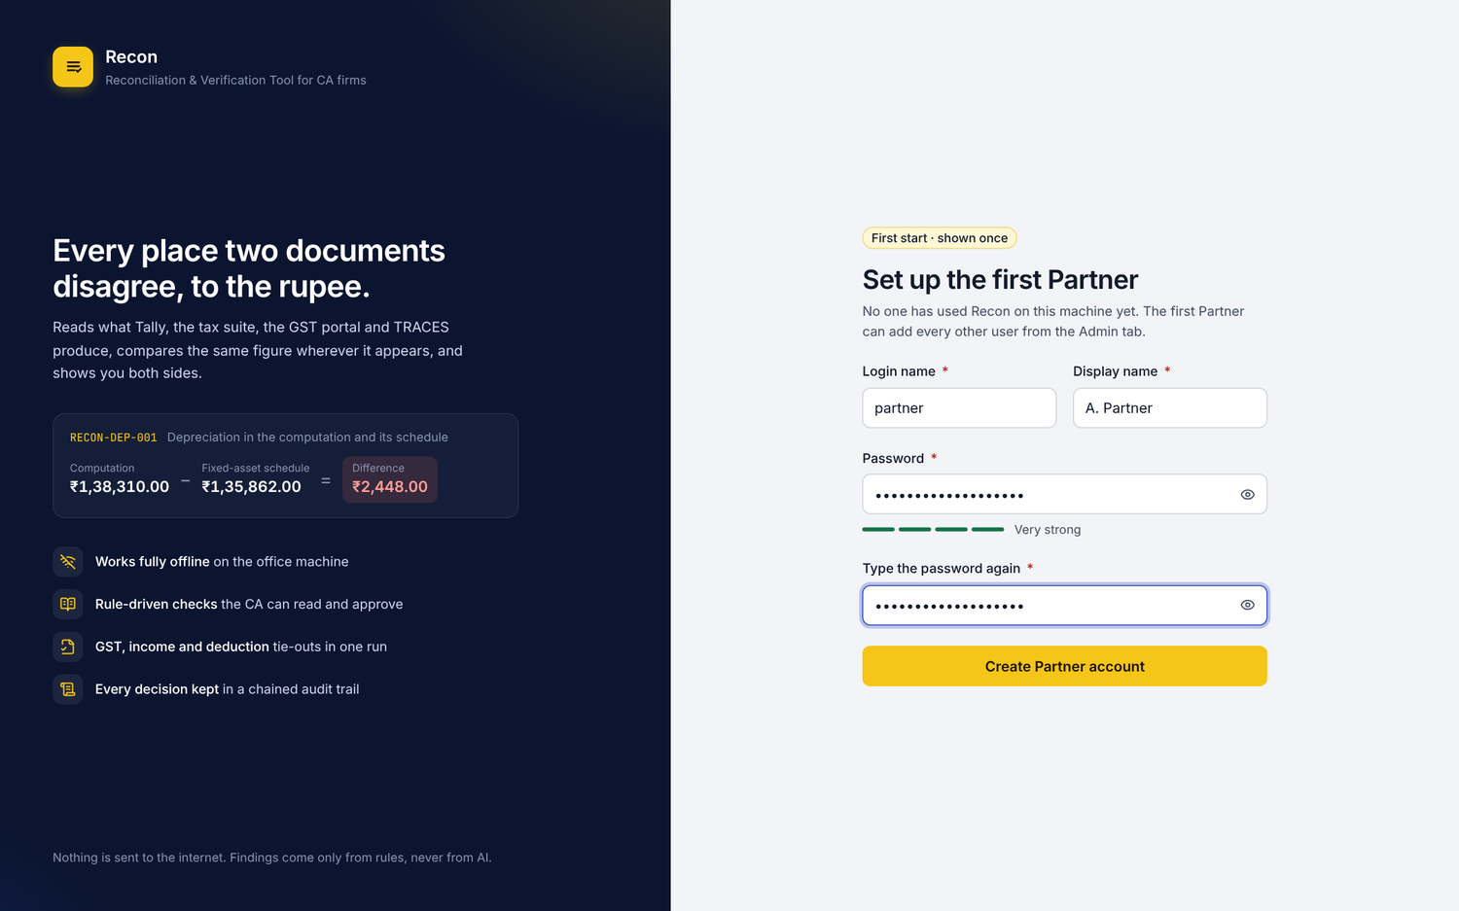

4.2 Sign in
The left panel now shows what the tool does with a real example finding (A − B = difference) and the four promises: offline, readable rules, GST/income/deduction tie-outs, chained audit trail. Wrong passwords say how many tries are left before the lock; a locked account says for how long and that a Partner can unlock it. Users with a starting password go to Choose your own password before anything else.
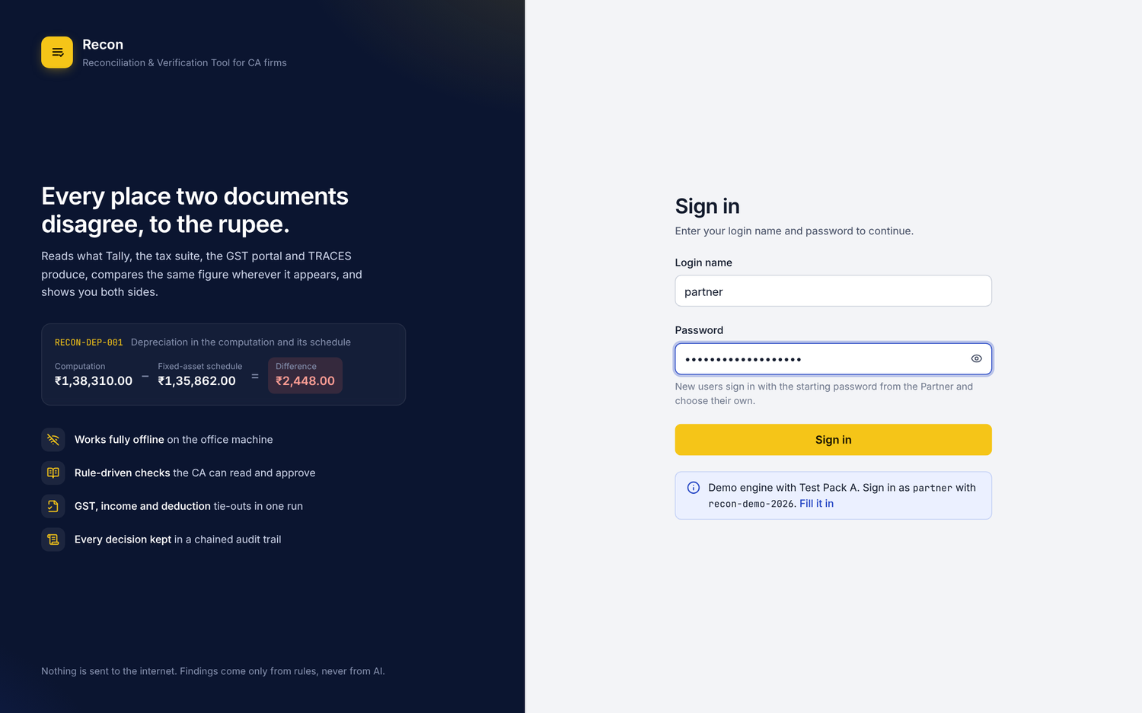

5. Season board (tab 1)

5.1 An empty board
A new season shows the three steps of the journey and one Add client button (key n).
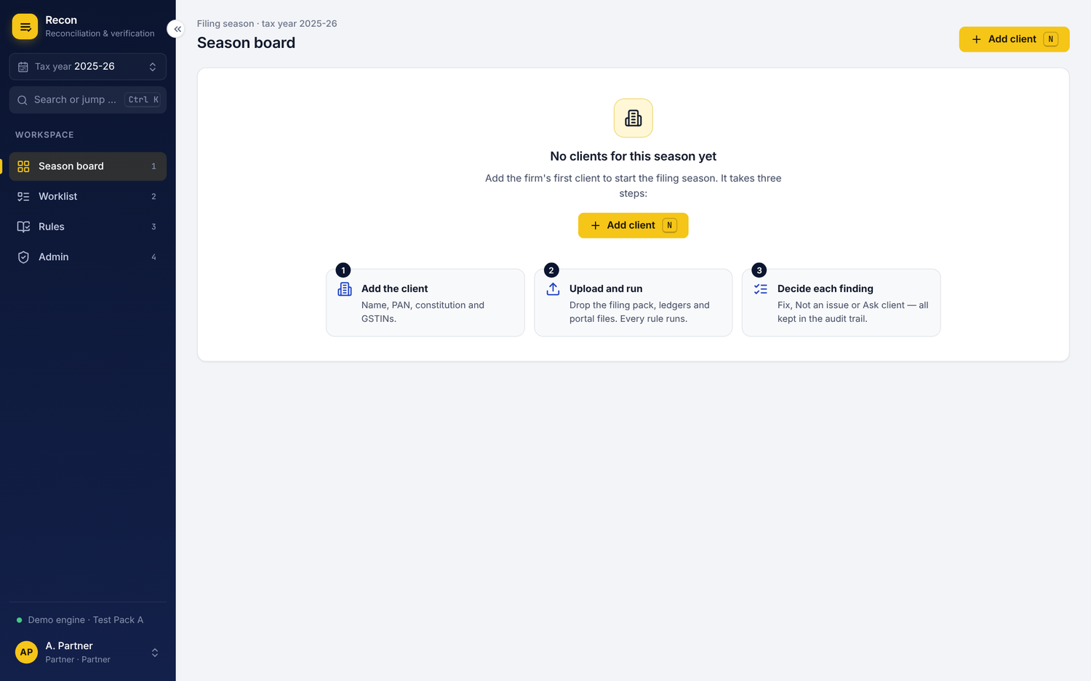

5.2 Add client
A right-side drawer in three labelled sections: Identity, GST registrations, Address, contact and software. Required fields carry a star; everything else is marked Optional.
- PAN, TAN, GSTIN and PIN are checked as they are typed, with the message under the field.
- A GSTIN is added with Enter, shows its state from the first two digits, and warns if it does not contain the PAN.
- The full PAN is never shown again after saving; Edit client shows "ending 821K, leave empty to keep it".
- Ctrl Enter saves. After saving, the new client's file opens with the next step.
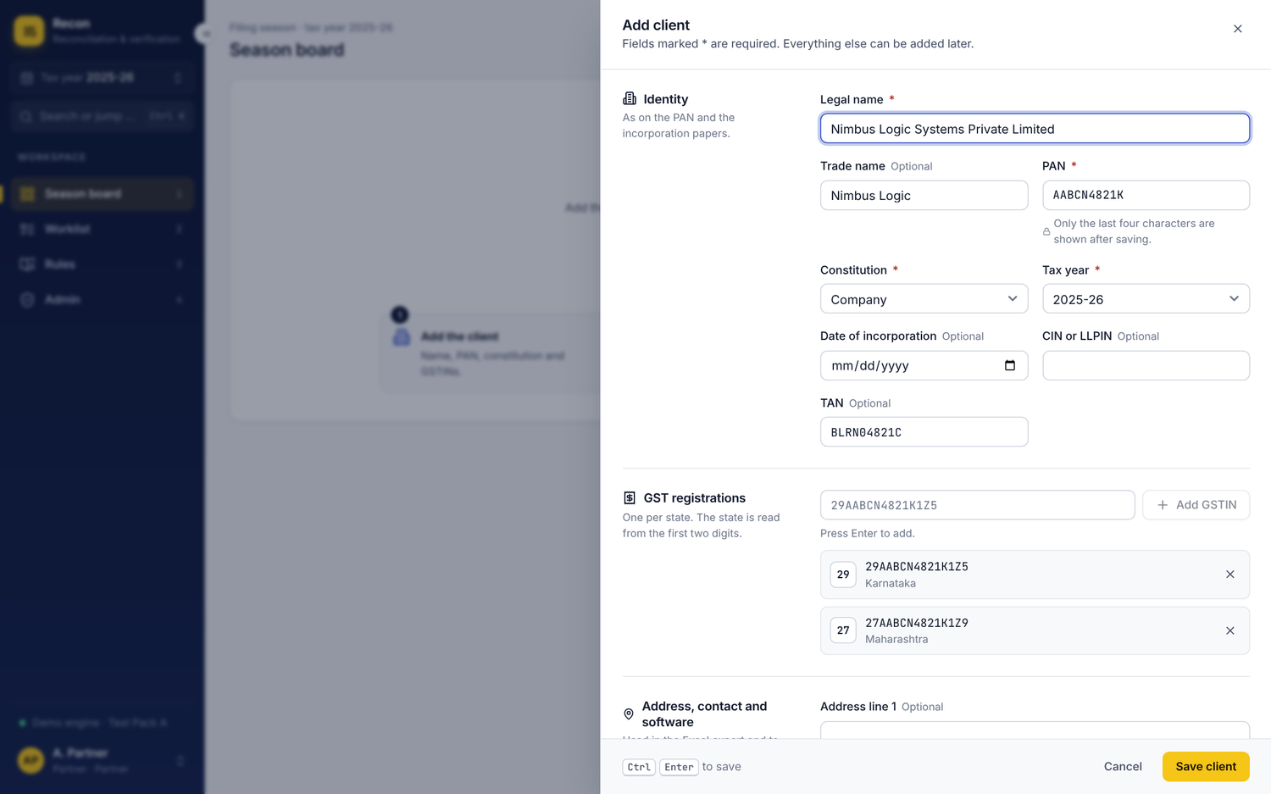

5.3 The board during the season
One KPI strip: Clients, With findings to review, Findings decided, Cannot check, No run yet. Clicking a tile filters the table; the season progress bar below shows the share of findings decided. The table shows each client with constitution and city, PAN ending, last run (relative, exact on hover), files read, open of total findings with a progress meter, cannot-check count and status. Rows are sorted by status by default so clients needing work come first. Arrow keys or j/k move, Enter opens, / searches.
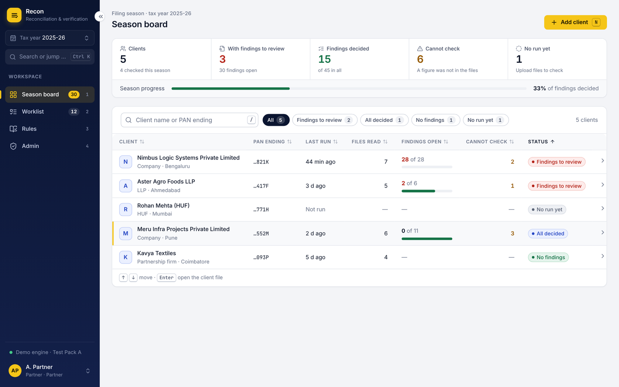

6. Client file: upload and run

6.1 A new client
The header carries everything about the client in one row: avatar, legal name, PAN ending, constitution, city, GSTIN count, accounting software and Edit client; on the right, Results for (tax year), Export Excel and Upload and run (key u). Before any run, the page explains the next step and lists the three kinds of files to bring. Files can be dropped anywhere on the page.
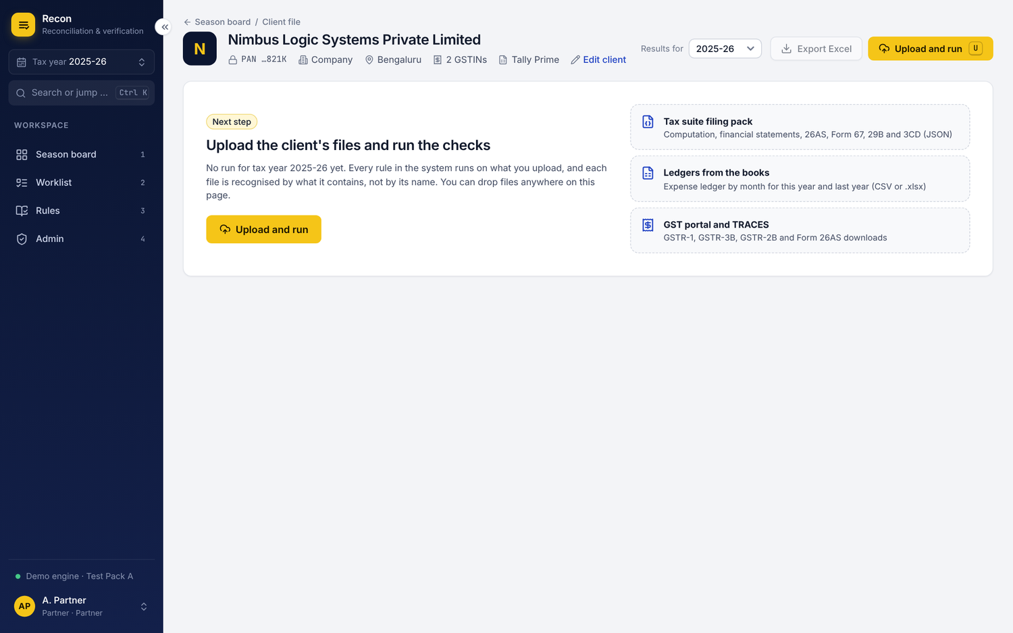

6.2 Upload and run
The panel keeps the rule "every rule runs on what you upload; nothing to choose" and says how many rules can run today. Each file is checked as soon as it is added and shows what it was recognised as, which documents it holds and its tax year, before the run starts. The tax year is worked out from the files, with the same note as before about last year's ledger. The switch Include rules not yet approved by the CA sits next to Run checks, and the button says how many files will be read.
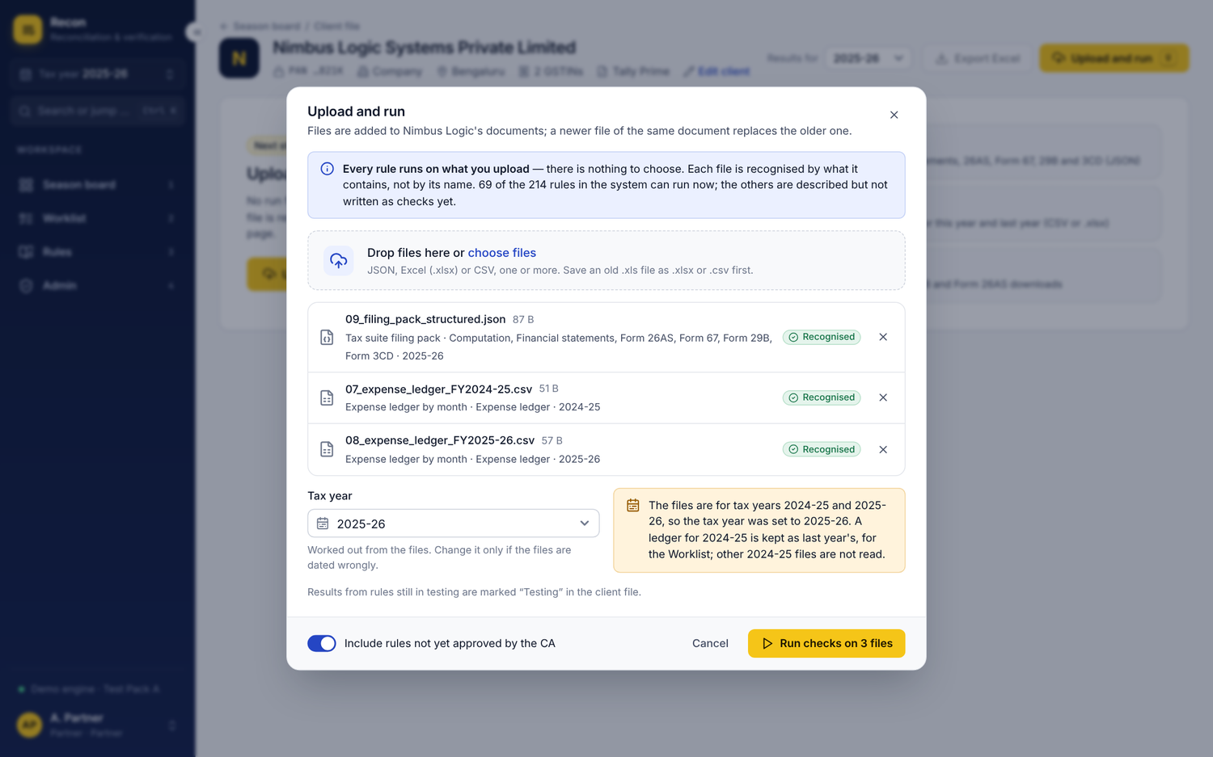
While the run happens, the panel shows four steps: reading the files, recognising each document, running every rule, saving the result. A toast then reports the run number and counts.
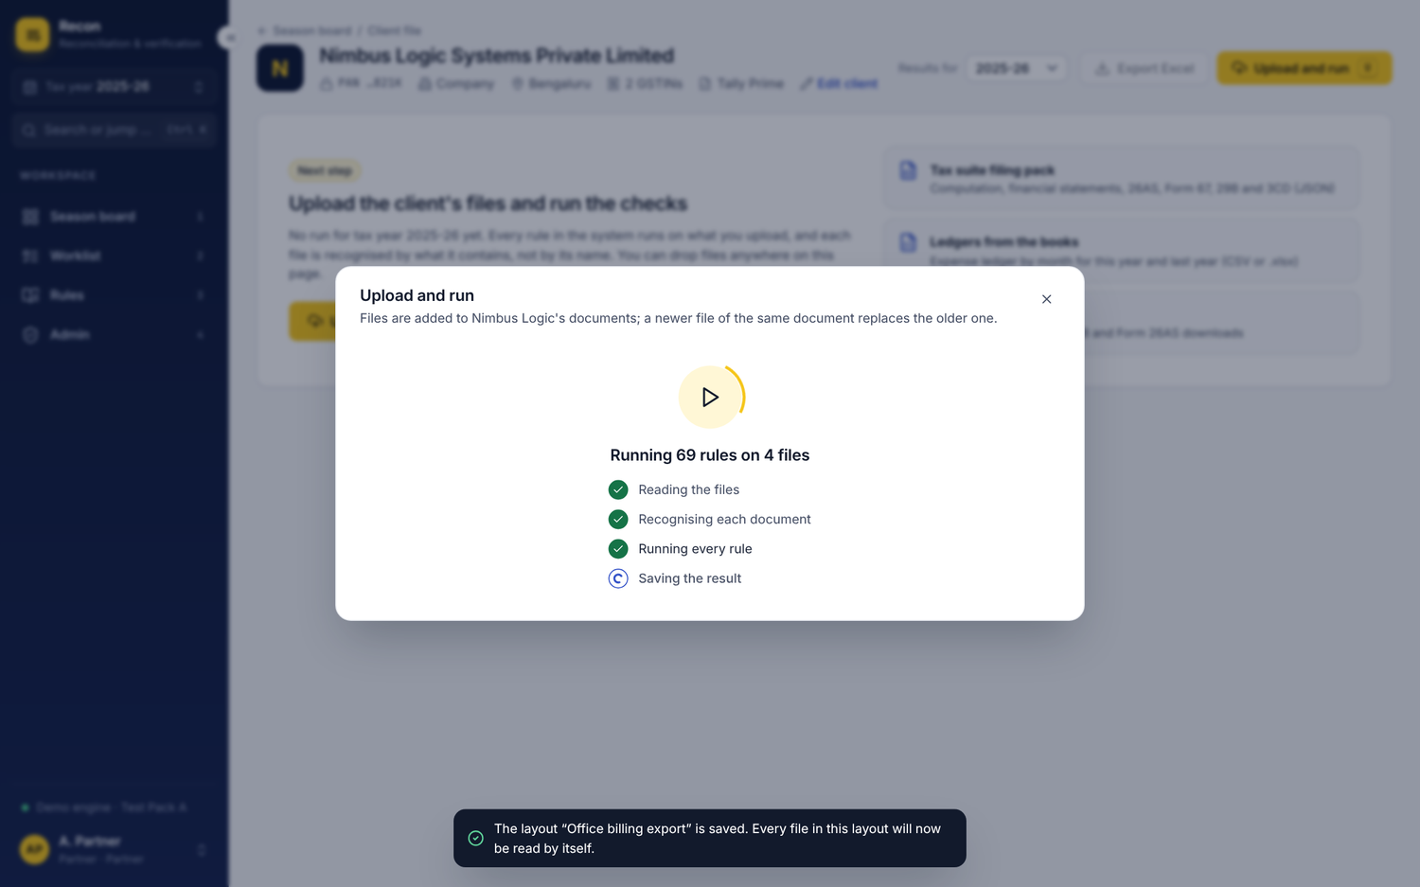

6.3 A file the tool does not know: Teach this layout
An unknown file is marked in amber with "The file matches no known format" and a Teach this layout button on its own row; an old .xls is marked in red with what to do.
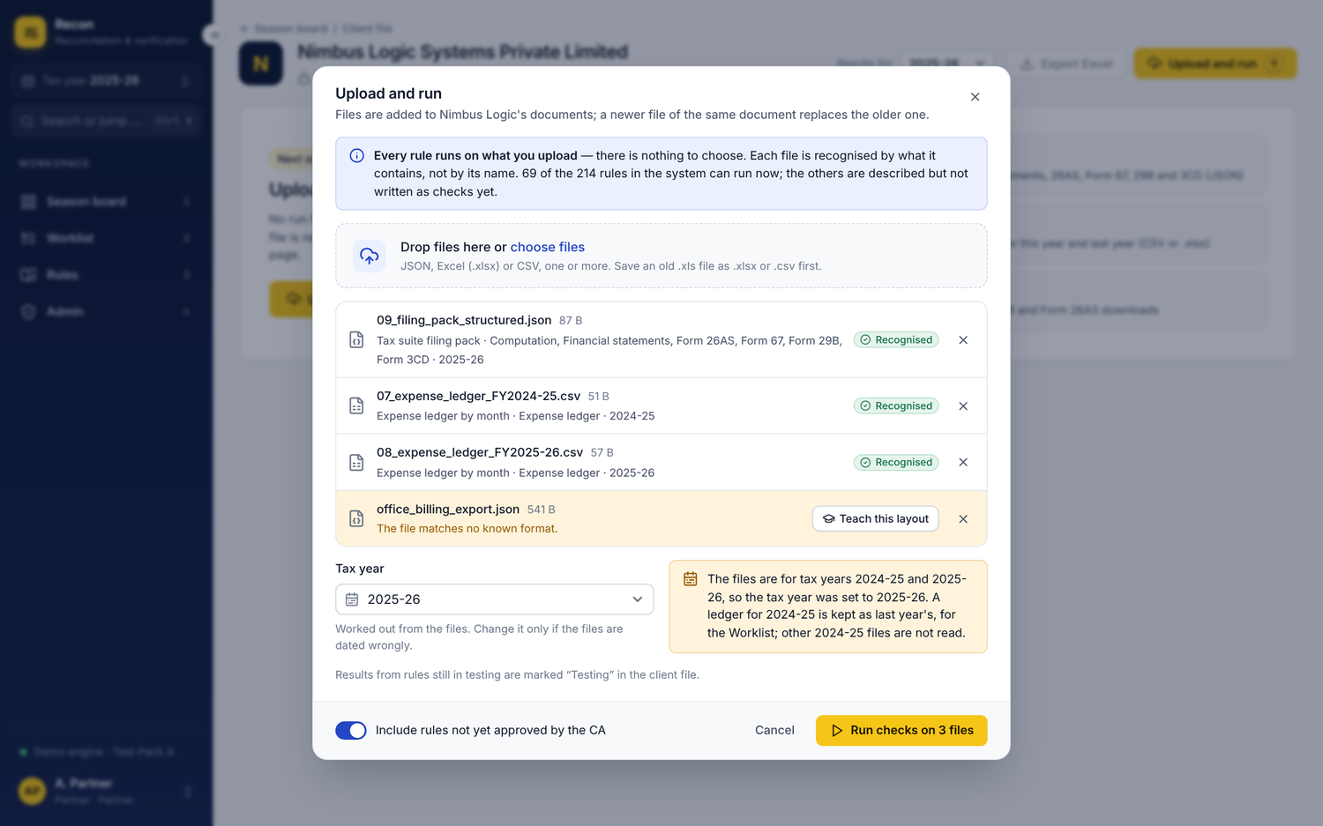
The mapping is a three-step wizard: About the file (name, document, list of rows, rupees or paise), Map the columns, Preview and save. Columns are suggested from the field names and marked Suggested until the user changes or confirms them. The first row of the file stays on the right, and each field already mapped is labelled with its column.
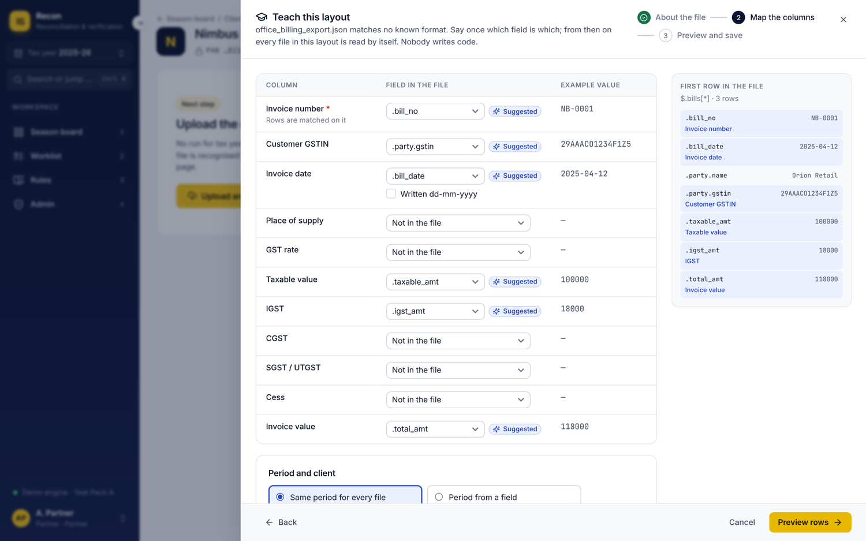
The preview runs on its own when step 3 opens and shows the rows exactly as they will be read, with the place each came from. A wrong choice gives a clear error and a link back to the columns. Save layout is enabled only when the rows read correctly.
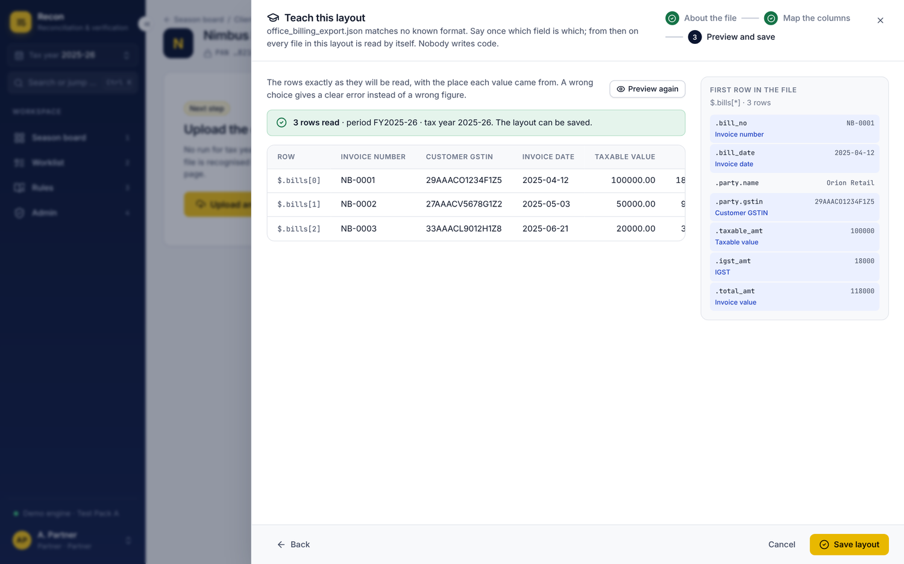

7. Client file: the result

7.1 Result summary
The summary card shows the run (Run 2, latest, date and time, tax year), then Checks, Pass, Findings and Cannot check, and on the right Open, no decision yet with how many are decided. A bar shows pass, findings and cannot-check in proportion. When the run included rules not yet approved by the CA, an amber note says so and explains the Testing label. Example: 69 checks, 39 pass, 28 findings, 2 cannot check, 28 open.
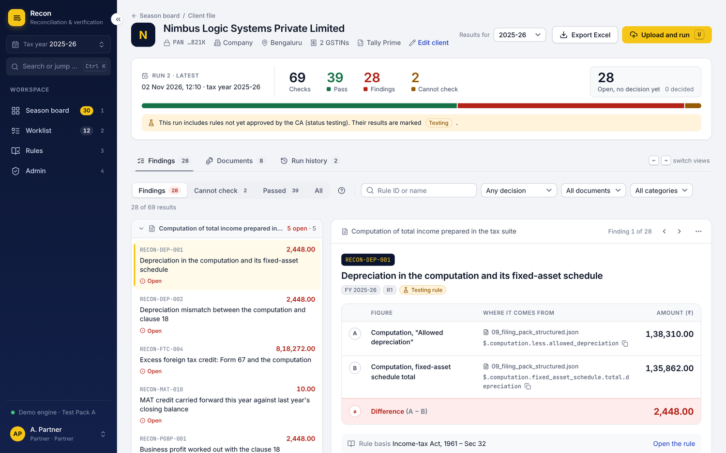

7.2 Findings, grouped by the document to fix
Findings are still grouped by the document that needs fixing, because that is how the work is handed out. The result filter (Findings / Cannot check / Passed / All) shows counts; search, decision, document and category filters sit on one line, with Clear when any is set. The ? button explains result, finding and cannot check.
The list stays beside the detail and keeps its place while the detail scrolls. Each group header shows the document, how many are open and the total, and can be collapsed. Each line shows the rule ID, name, difference and its decision (or Open).
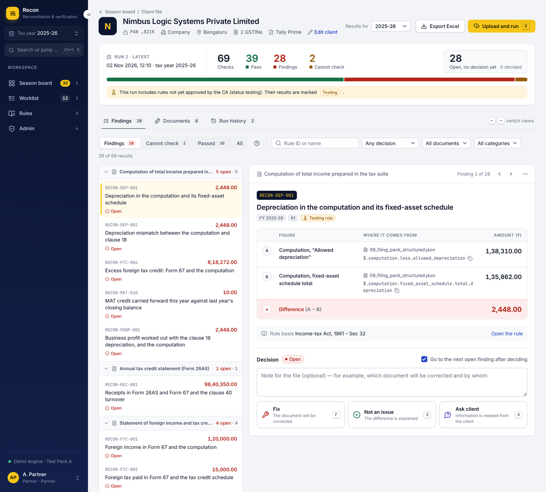

7.3 One finding
The two figures are shown as rows in one table, so they read top to bottom like a working paper. Columns: Figure (the label), Where it comes from (file name and the exact location inside the file, with a copy button) and Amount (₹), right-aligned in Indian grouping. Row A is the first figure, row B the second, and the last row, shaded red, is Difference (A − B). For a passed check the last row is green. This replaces the side-by-side boxes and the separate sum line, which were hard to read. The tool still states only what it can compute and never says which figure is right. Previous and next (k and j) sit in the panel header with "Finding 1 of 28".
Row | Figure | Where it comes from | Amount (₹)
A | Computation, "Allowed depreciation" | 09_filing_pack_structured.json · $.computation.less.allowed_depreciation | 1,38,310.00
B | Computation, fixed-asset schedule total | 09_filing_pack_structured.json · $.computation.fixed_asset_schedule.total.depreciation | 1,35,862.00
Difference (A − B) |  |  | 2,448.00
On a phone each row stacks: label, source, then amount, with the difference row last.

7.4 Deciding a finding
An optional note, then three decision cards that each say what they mean: Fix (the document will be corrected), Not an issue (the difference is explained), Ask client (information is needed from the client). Keys f, x and a do the same. After deciding, the panel moves to the next open finding (this can be turned off). The decision history appears under the cards, newest first, with who, when and the note, and a line confirming that decisions are added on top, never overwritten, and follow the finding into later runs.
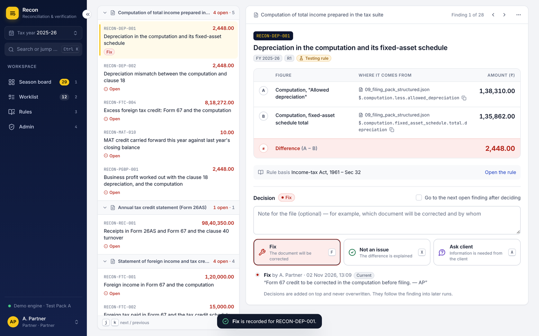
A Partner or Manager deletes a finding from the … menu. The confirmation needs a reason, which is kept in the audit trail.
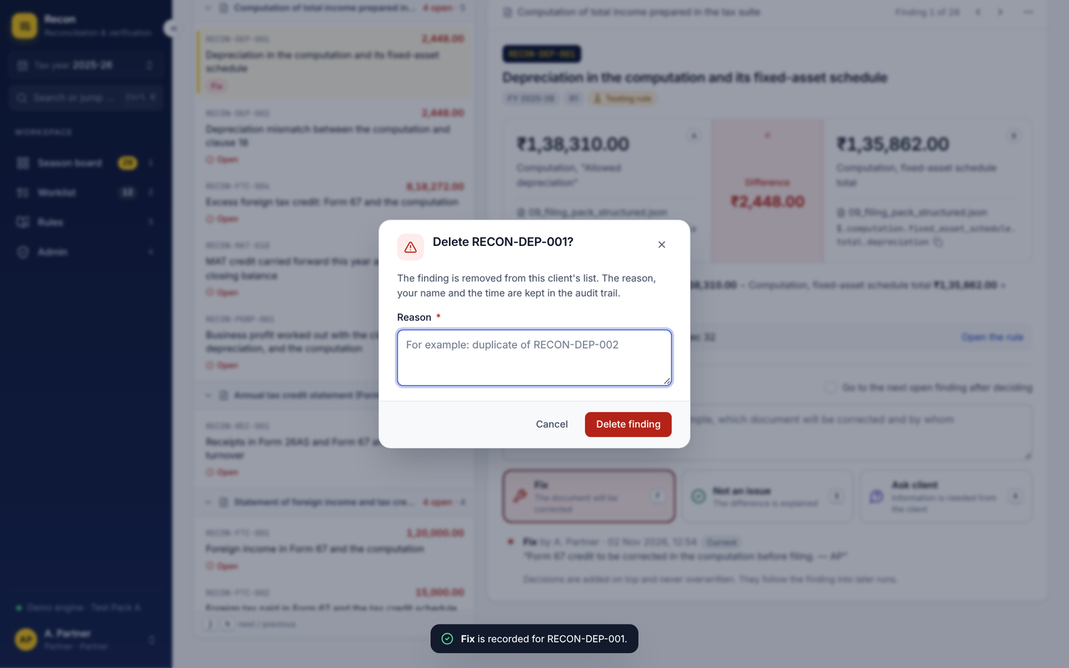
A cannot-check result shows why the figure was missing and what to upload.
[image: Cannot check]

8. Documents and Run history

8.1 Documents: what was read from each file
Four totals open the view: files uploaded, documents recognised, figures read by the checks, values no check uses yet. The table groups each file with the documents it holds (the Test Pack A filing pack holds six), and each row shows what it was recognised as, the format and version, tax year, how much was read, a coverage bar of read against not read, and any problem (for example, last year's ledger kept for the Worklist only).
[image: Documents view]
Opening a row shows a drawer with every location in the file, its value, and whether it was read or why not, with a filter and search.
[image: What was read from one document]

8.2 Run history
Every run is a card on a timeline with its date and time, a result bar, pass / findings / cannot-check counts, the change in findings from the previous run, the files and drafts it read, and whether it included testing rules. Open read only shows an earlier run exactly as reported.
[image: Run history]
An earlier run opens with an amber banner ("Run 1, read only") and a button back to the latest run. Decisions cannot be made there.
[image: An earlier run, read only]

9. Worklist (tab 2)
The Worklist still lists ledger heads that are new, vanished, missing months or a step change, and still never fills in the classification. The top card shows how many are left to classify with a progress bar, and filter chips for each change type with counts.
Each row shows the ledger head with client and sector, what changed (with the % change for step changes), last year and this year in lakh with months counted, a 12-month strip (April to March; a dashed month had an entry last year only) and the classification field.
[image: Worklist: 12 items to classify]
Staff type the classification (suggestions such as "Clause 44: GST registered supplier" or "TDS 194J: professional fees" appear as they type) and press Enter or Save. A saved row turns green with who saved it and an edit button. Ticking several rows opens a bar at the bottom to classify them together. Every save shows a toast with Undo. "Only items not classified" hides the finished ones and is remembered.
[image: One item classified, two selected for bulk classify]

10. Rules (tab 3)

10.1 The rule book
Five tiles lead the page: Rules in the book (and how many can run as checks), Approved, Testing, Switched off (described only), Disabled. Clicking a tile filters the table. One filter row holds search (/), tax year, type, subject, category and source. The table is sortable and shows rule ID, name (with "Described only, not run yet"), type and subject, category, tax years, status and source, 25 rows a page.
[image: Rules]

10.2 One rule
The rule opens in a drawer. A readiness note says plainly whether it can be approved and, if not, why (for example: it has not yet run on a client with testing rules included). Below: rule text, type, subject, category, tax years, validity, version, file, the two figures it compares, and every version with who made it and which is in use. The footer holds Disable (with confirmation), Reset to standard (office changes only), Edit this rule, and Approve for a Partner, enabled only when the rule is ready.
[image: Rule detail]

10.3 The Rule Builder
A full page with section navigation on the left: Who and what, Where it applies, What it reads, The check, Examples. The navigation shows how many required fields are left. Tax years and record types are toggle chips; facts are picked from the vocabulary. The check is first figure, "should be", second figure and tolerance in rupees, and a live sentence states exactly when a finding will be raised. A passing and a failing example are required. The fixed bar at the bottom offers Save as testing (Ctrl S) and, for a Partner, Save and approve.
[image: Rule Builder]
[image: The check and examples]

11. Admin (tab 4, Partner only)
Admin now has three tabs: Users, Sign-in security, Audit log. Every change is still written to the audit log with the Partner's login name.

11.1 Users
The table shows each user with avatar, name and login, role, status (Active, Must change password, Locked, Disabled) and last sign-in. "What each role can do" opens a matrix of the four roles against nine actions. Add a user opens a dialog with a role picker that explains each role and a Suggest button for the starting password.
[image: Add a user]
Manage opens a drawer to change the role, reset the password (the user must choose their own at the next sign-in), unlock, or disable the account (with confirmation). A Partner cannot change their own role or disable themselves.
[image: Manage a user]

11.2 Sign-in security
Lockout settings (failed sign-ins 1 to 20, minutes locked 1 to 1440) with a sentence that reads the settings back, Save only when something changed, and a short list of how sign-in is protected.
[image: Sign-in security]

11.3 Audit log
A green banner confirms the chain is intact and how many entries it holds (a red one would say it is broken). The log can be searched and filtered by who and by action, newest first, 25 a page, with each action shown as a coloured tag.
[image: Audit log]

12. Shortcuts, search, dark theme and phone

12.1 Shortcuts sheet and search
? opens the full sheet, grouped into Anywhere, Lists and tables, and Client file. Ctrl K opens search across clients, rules and actions.
[image: Keyboard shortcuts]
[image: Search or jump]

12.2 Dark theme
Every colour has a dark value; semantic colours are lightened to keep contrast. The theme follows the computer unless the user picks Light or Dark in the user menu.
[image: Client file in the dark theme]

12.3 Phone and tablet
Below 900 px the rail becomes a slide-in menu behind a top bar; the findings list stacks above the detail; the A / difference / B equation stacks vertically; tables scroll inside their card, never the page. Buttons and rows keep touch-sized targets.
[image: Season board on a phone]
[image: A finding on a phone]

13. Build notes for Go + React / Vite
The front end is React 18 + TypeScript on Vite 5, with TanStack Query for data, React Router 6, lucide icons and plain CSS on the token file. No UI framework is added. npm run build writes dist/, which the Go server embeds and serves, returning index.html for any unknown path. The mock engine is selected only when VITE_API_MODE=mock.

Folders
Path | Holds
src/styles/ | tokens.css (design tokens, light + dark), base.css, components.css, layout.css, features.css
src/components/ | ui.tsx (button, field, badge, money, stack bar, sortable header, pagination, month strip, segmented) and overlay.tsx (dialog, drawer, menu, toasts, confirm)
src/app/ | App routing, shell with rail, command palette, shortcuts sheet, session / theme / tax-year context
src/api/ | types.ts (domain model), client.ts (the Api interface), http.ts (Go engine), mock.ts + mockData.ts (Test Pack A)
src/features/ | auth, season, client (file, findings, documents, history, upload, layout wizard, client drawer), worklist, rules, admin
src/lib/, src/hooks/ | Formatting (Indian money, dates), labels, role permissions, hotkeys, remembered preferences

API contract the screens expect
All routes are under /api, JSON in and out, session in an HttpOnly same-site cookie. Errors return { "error": "plain message", "code"?: "..." } with a 4xx status; the message is shown to the user as written. Money is always integer paise.
Method and path | Purpose
GET /status | Engine version, needsSetup, rules total and runnable
POST /auth/setup, /auth/login, /auth/logout, /auth/password; GET /auth/me | First Partner, sign-in, sign-out, change password, current session (401 when signed out)
GET /tax-years; GET /season?taxYear= | Tax years; season summary and client rows
GET / POST /clients, GET / PUT /clients/{id} | Client read, add, edit (PAN accepted, only last four returned)
GET /clients/{id}/result?taxYear=&run= | Results, documents read, runs; readOnly for earlier runs
POST /clients/{id}/uploads/plan (multipart) | Recognise files before running; tax-year note
POST /clients/{id}/runs (multipart + taxYear, includeTesting) | Run every rule
POST /clients/{id}/results/{rid}/decisions; DELETE /clients/{id}/results/{rid} | Add a decision; delete a finding with a reason
GET /clients/{id}/export.xlsx?taxYear= | Excel export
POST /layouts/inspect, /layouts/preview, /layouts (multipart + mapping) | Teach this layout
GET /worklist?taxYear=; POST /worklist/classify | Worklist items; classify one or many (empty string undoes)
GET / POST /rules; GET / PUT /rules/{id}; POST /rules/{id}/approve, /enable, /disable, /reset | Rule book and Rule Builder
GET / POST /admin/users; PATCH /admin/users/{id}; POST /admin/users/{id}/password | Users
GET / PUT /admin/lockout; GET /admin/audit | Lockout settings; audit log with intact flag
The full request and response shapes are the TypeScript types in src/api/types.ts.

Roles (unchanged)
Action | Partner | Manager | Staff | Read-only
View | Yes | Yes | Yes | Yes
Upload and run, decide findings, draft rules | Yes | Yes | Yes | No
Classify the Worklist | Yes | Yes | Yes | No
Delete findings, export, disable rules | Yes | Yes | No | No
Approve rules, Admin tab | Yes | No | No | No
The screens hide or disable what a role cannot do; the engine must still enforce every permission.

How to run
- npm install
- With the Go engine on port 8080: npm run dev (Vite proxies /api; change the target with VITE_API_TARGET).
- Without the engine: VITE_API_MODE=mock npm run dev, sign in as partner / recon-demo-2026. Add ?fresh=1 to the URL to start from an empty database and see first-Partner setup.
- npm run build for the Go embed; vite build --mode preview for the single-file design preview.

Open questions for the engine team
- ☐ Confirm the route names above or send the existing ones; only src/api/http.ts needs to change.
- ☐ Does the engine already return per-file recognition before a run (the upload plan), or should the screen run the plan on the first Run checks?
- ☐ Should Worklist classification suggestions come from the firm's past classifications instead of the fixed list?

